110522130 資工碩一 李信鋌

110526005 資工碩一 林季陽

資料科學實務 – Lab Activity GAN

The code we have written for this assignment.

Train the model with the original datatset. (100 photos of zero digit and 1000 photos of one digit)

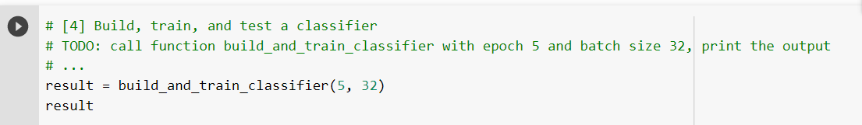

The following photo is our result.

The final accuracy is 91% after 5 training epochs.

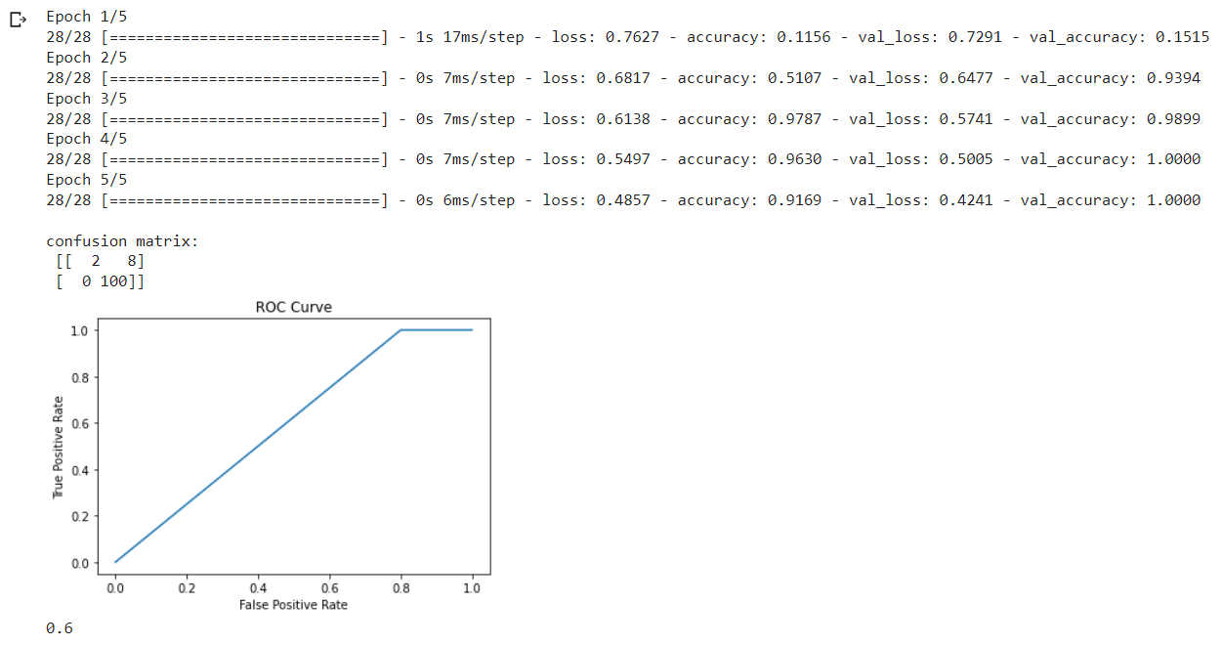

0.6 is Area Under the Curve (AUC) using the trapezoidal rule.

Formula: (1.0 + 0.2) \* 1 / 2 = 0.6

We are going to build and train the GAN for data augmentation.



The following photo is our result.

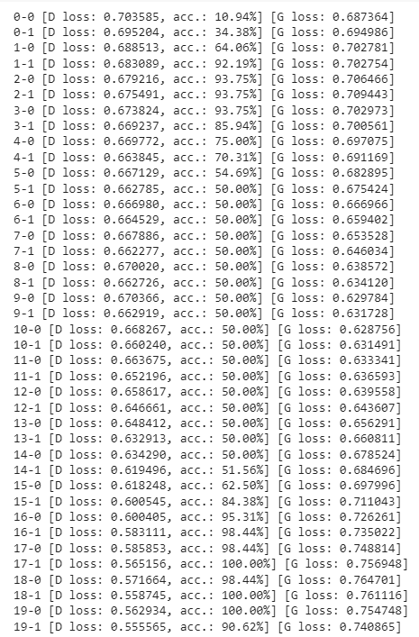

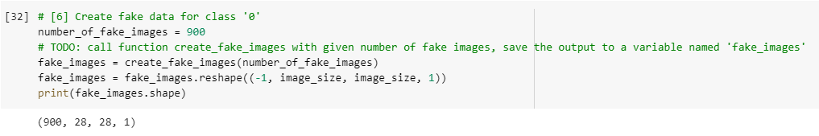

We create 900 fake images of number 0.

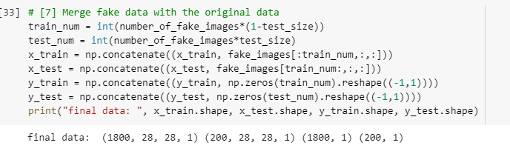

We combine the fake image above to the training data, but not testing data.

It is because the number of training data is 1800.

Because the number of testing data is remain unchanged after adding training data.

Build and train the model with the new datasets.

Accuracy before using GAN to augment new photos: 91.7%

Accuracy after using GAN to augment new photos: 98%

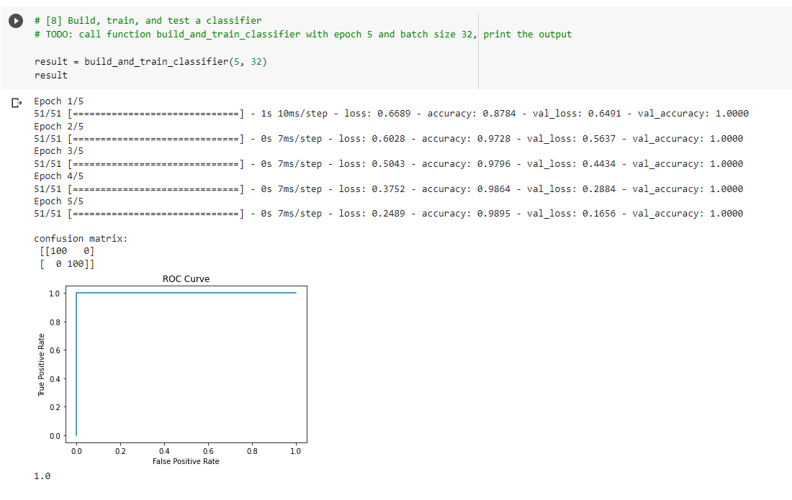

ROC curve is 1 because 1 \* 1 = 1.